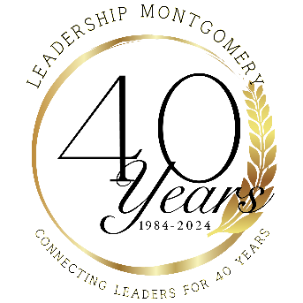

Leadership Legacy Award
Presented at
2024 Legacy Class XL Graduation

Thursday, May 16, 2024

Purpose: The Leadership Legacy Award, in honor of our Leadership Montgomery Founders, recognizes and rewards a Leadership Montgomery Alumni whose contributions through exceptional leadership has made a difference in Montgomery:

- Vision – The talent to articulate a dream and direction that other people want to share and follow.
- Innovation – The ability to be creative and “think outside the box.”
- Courage – The strength to challenge the status quo for the betterment of the lives of others.
- Inspiration – The power to implement a vision through others.

This award is not based on the recipient’s views, organization, opinions or the environment within which the recipient demonstrated outstanding leadership. The award’s intent is to focus on the commitment, courage, and positive contribution of the recipient’s leadership.

Eligibility: The nominee must meet the following criteria:
- Must be an alumni of Leadership Montgomery
- Nominee must embody the mission and purpose set forth by the founders of Leadership Montgomery.
- Nominee may have exhibited his/her leadership in a voluntary capacity or in the exercise of his/her employment

Award: The recipient will receive an award in honor of the founders of Leadership Montgomery.

Deadline: Nominations must be received by Leadership Montgomery no later than 5:00pm, Monday,
May 6, 2024
.
Please email nominations to cheryl.johnson@leadershipmontgomery.org

The information on the nomination form will be considered confidential
and only reviewed by the Selection Committee.

For more information, contact Cheryl Johnson, 334-558-8446 or email cheryl.johnson@leadershipmontgomery.org

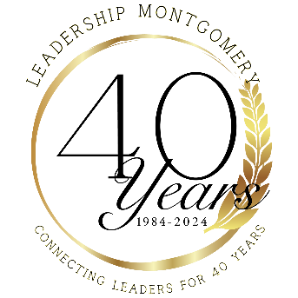

Leadership Legacy Award Nomination Form

NOMINATION SUBMISSION DEADLINE: May 6, 2024

Nominee

Name __________________________________________________________________________
Title (If applicable) _______________________________________________________________
Company/Organization _____________________________________________________________
Address _________________________________________________________________________
City ___________________________________ State ______________ Zip __________________
Work Phone ___________________________ Home Phone _______________________________

Reasons for this Nomination

All information presented should be accurate and complete. Strive to provide a description of the nominee that positively sets forth accomplishments and a demonstrated record of achievement that furthers the spirit of Leadership Montgomery. Present the justification for your nomination on no more than two typed pages double-spaced in 12-point size.

Application suggestions:
- Focus on nominee’s achievements, rather than those of his/her organization.
- For a nominee exhibiting leadership in the exercise of employment, focus on how she/he has gone beyond his/her professional responsibility.
- Describe how the nominee’s leadership activities and achievements made a lasting and meaningful impact on the quality of life in Montgomery County.

Nominator

Name (Please print) _____________________________________ Date ______________________
Company/Organization _____________________________________________________________
Address _________________________________________________________________________
City ___________________________________ State ______________ Zip __________________
Work Phone ___________________________ Home Phone _______________________________
Signature ________________________________________________________________________
Deadline for Submission: 5:00pm, Monday, May 6, 2024
Email the nomination form to cheryl.johnson@leadershipmontgomery.org

